BSIT III course work

Create a web project with at-least two tables:

Create a page to display a table as shown in the image below.

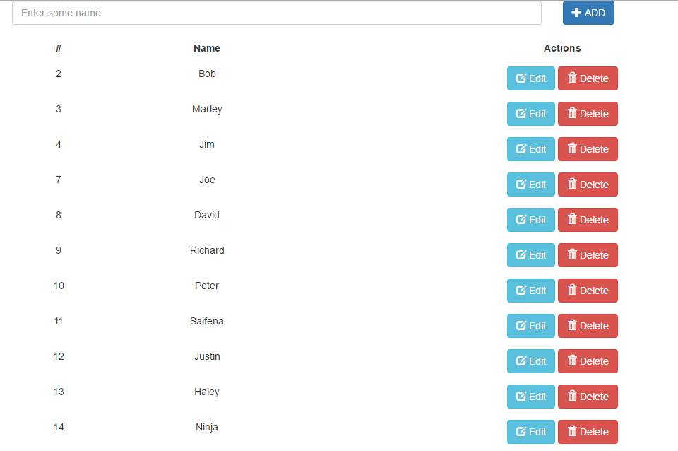

Add buttons as shown to delete and edit which should take the user to the edit page.

Use smarty templating and red bean libraries

Add a login page for two users -one should be able to delete and the other should not